Erik Marrero

Cs 152

Homework 6

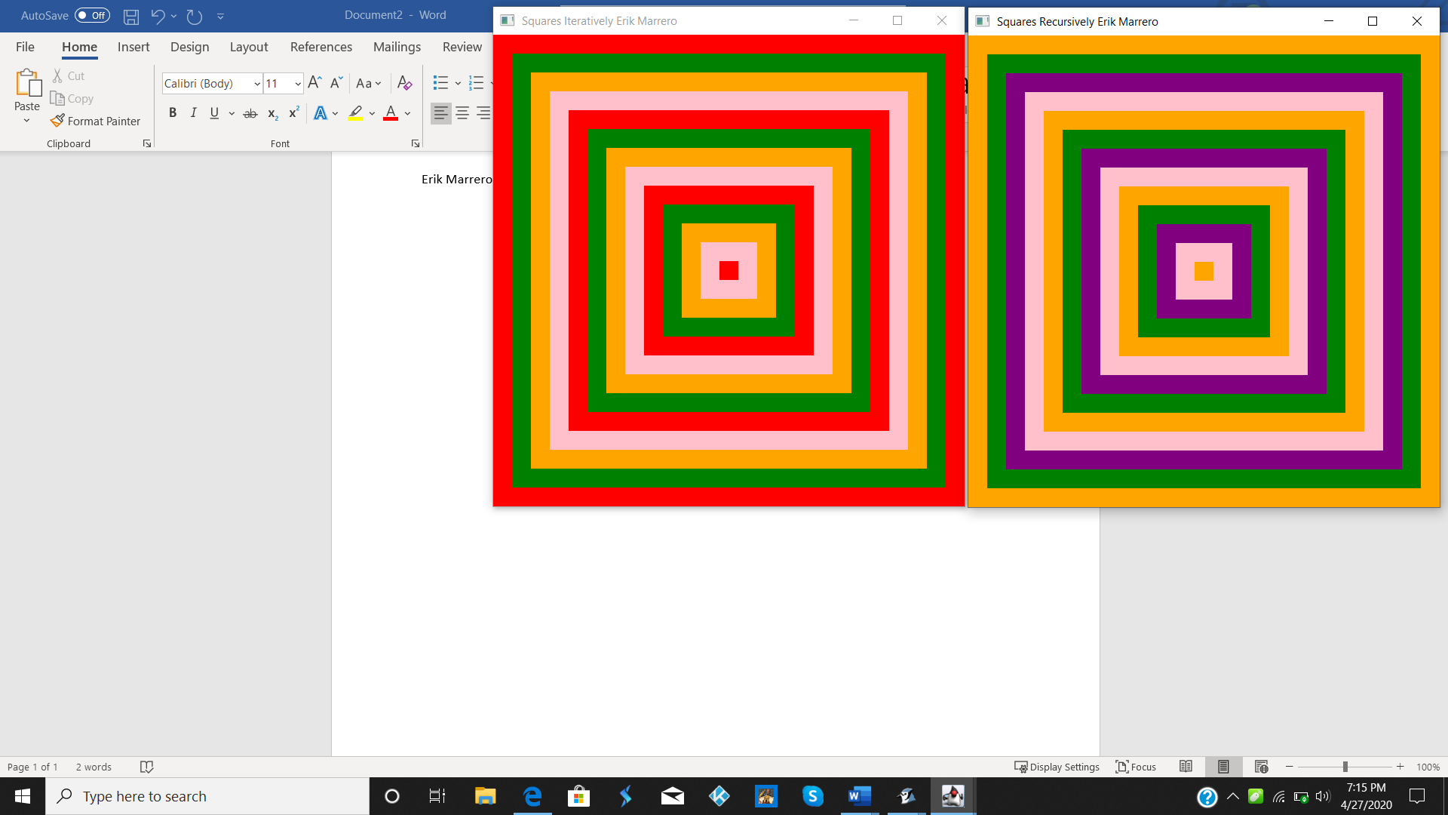

import javafx.application.Application;

import javafx.scene.Group;

import javafx.scene.Scene;

import javafx.scene.paint.Color;

import javafx.scene.shape.Rectangle;

import javafx.stage.Stage;

public class ConcentricSquares extends Application {

private final int SIZE = 500;

private final int DIST = 20;

public void concentricSquares4colorFill(int xy, int color, Group g) {

Rectangle rec;

for (int i = xy; i < SIZE / 2; i += DIST) {

rec = new Rectangle(i, i, SIZE - 2 \* i, SIZE - 2 \* i);

if (color % 4 == 0)

rec.setFill(Color.RED);

else if (color % 4 == 1)

rec.setFill(Color.GREEN);

else if (color % 4 == 2)

rec.setFill(Color.ORANGE);

else

rec.setFill(Color.PINK);

g.getChildren().add(rec);

color++;

}

}

public void concentricSquares4colorFillRec(int xy, int color, Group g) {

Rectangle rec;

Color eColor;

if (xy < SIZE / 2) {

if (color % 4 == 0)

eColor = Color.ORANGE;

else if (color % 4 == 1)

eColor = Color.GREEN;

else if (color % 4 == 2)

eColor = Color.PURPLE;

else

eColor = Color.PINK;

rec = new Rectangle(xy, xy, SIZE - 2 \* xy, SIZE - 2 \* xy);

rec.setFill(eColor);

g.getChildren().add(rec);

concentricSquares4colorFillRec(xy + DIST, color + 1, g);

}

}

public void start(Stage stage) throws Exception {

Group root = new Group();

concentricSquares4colorFill(0, 0, root);

Scene scene = new Scene(root, SIZE, SIZE, Color.PALEGREEN);

stage.setTitle(" Squares Iteratively Erik Marrero");

stage.setScene(scene);

stage.show();

Group root1 = new Group();

concentricSquares4colorFillRec(0, 0, root1);

Scene scene1 = new Scene(root1, SIZE, SIZE, Color.PALEGREEN);

Stage stage1 = new Stage();

stage1.setTitle(" Squares Recursively Erik Marrero");

stage1.setScene(scene1);

stage1.show();

}

}